BUSINESS ANALYSIS REPORT

Row Houses Construction

ARC TECHNOLOGIES AND INSTITUTIONS

BY

Dipali Mendhe

DA 15

Contents

Executive Summary 2

Project Location 2

Project Vision 2

Design and Architecture 2

Amenities and Features 2

Project Timeline 2

Scrum Framework Overview 3

Roles and Responsibilities 3

Sprint Planning 4

Product Backlog 5

User stories 5

JIRA 6

Conclusion 6

List of Figure

Figure 1. Scrum Framework 3

Figure 2. Sprint Planning 4

Figure 3. Product Backlog 5

Figure 4. JIRA 6

# Executive Summary

This document describes the business analysis for the construction of row houses to develop a modern and sustainable residential community that offers the perfect blend of urban convenience and suburban calmness. The goal is to timely delivery, affordable, quality control, and client satisfaction.

## Project Location

The project site is situated in Nagpur, offering easy access to major highways, public transportation, grocery stores, malls, schools, and recreational facilities.

* **Project Name:** Row House Development Project
* **Location:** Besa, Nagpur
* **Project Type:** Residential Row Houses
* **Target Market:** Middle-class families, first-time homebuyers, investors
* **Project Duration:** 03 March 2025 – 03 November 2025

## Project Vision

Our vision is to create a successful community which promotes a high quality of life to its residents. We are committed to incorporating sustainable and innovative design to create homes that are not only beautiful but also environment friendly.

## Design and Architecture

The row houses in this project are designed in detail to ensure functionality, facilities, and sustainability. Each unit will have:

* Spacious layouts with 2-4 bedrooms
* Modern kitchen and bathroom designs
* Solar panels for energy efficiency
* Private outdoor spaces such as gardens or terraces
* High-quality construction materials and finishing

## Amenities and Features

The Row House Project will offer a range of amenities and features to enhance the living experience of its residents, including:

* Community clubhouse and parks
* Swimming pool and gym area
* Children's play areas and sports courts
* 24/7 security and surveillance

## Project Timeline

The project will be executed in multiple phases, with construction set to begin in 03 March 2025 and completion expected by 03 November 2025. Each phase will be carefully planned and executed to ensure timely delivery and minimal disruption to the surrounding community.

# Scrum Framework Overview

The overall project management has to be done using agile methodology including iterative development, collaboration, and flexibility. Below image show the scrum iteration developed for the construction of row houses using:

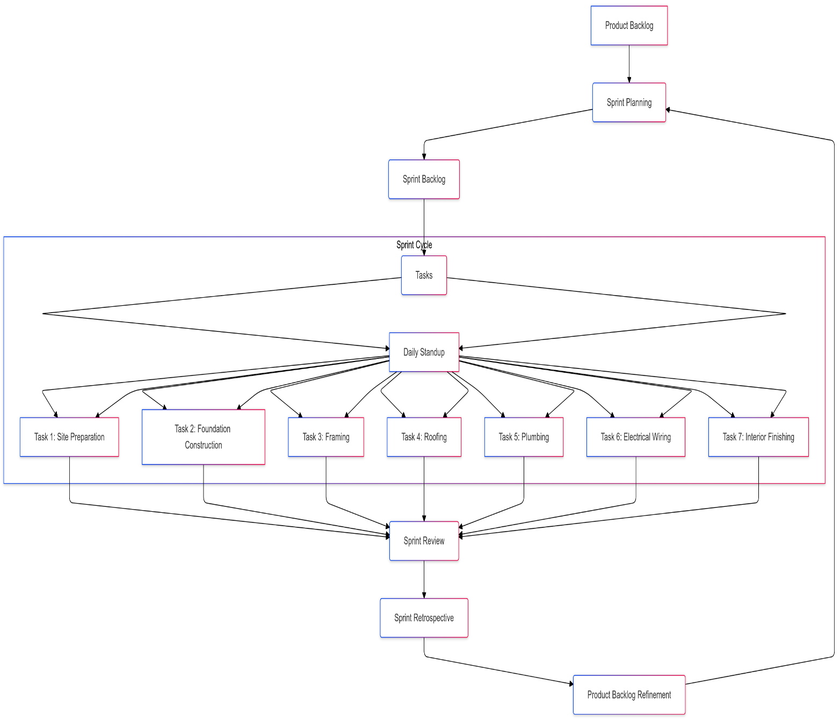

Figure . Scrum Framework

## Roles and Responsibilities

* **Project Manager:** Defines project vision, prioritizes tasks, and communicates with stakeholders.
* **Scrum Master:** Facilitates Agile processes and removes obstacles.
* **Construction Team:** Includes architects, civil engineers, interior designer, contractor, and surveyor and exterior designer.
* **Finishing Team:** Includes surveyor, landscaper, electrician, plumber and painter.

# Sprint Planning

Sprint planning and meetings has to be done in different phases

**Phase 1: Planning and Design**

* Conduct site surveys and feasibility studies.
* Develop architectural designs and blueprints.
* Obtain necessary permits and approvals.

**Phase 2: Infrastructure Development**

* Lay foundations and construct basic infrastructure (roads, utilities).
* Monitor progress and quality.

**Phase 3: Construction of Row Houses**

* Building the skeleton of the houses using wood, steel, or reinforced concrete.
* Constructing exterior walls and roofing, followed by internal walls.
* Adding insulation to walls, roofs, and floors.
* Perform regular inspections and quality checks.

**Phase 4: Finishing and Interiors**

* Complete interior work such as electrical, plumbing, carpentry.
* Install cabinets and finishes.

**Phase 5: Final Inspection and Handover**

* Conduct final inspections and quality assessments.
* Address any remaining issues and prepare for handover to clients.

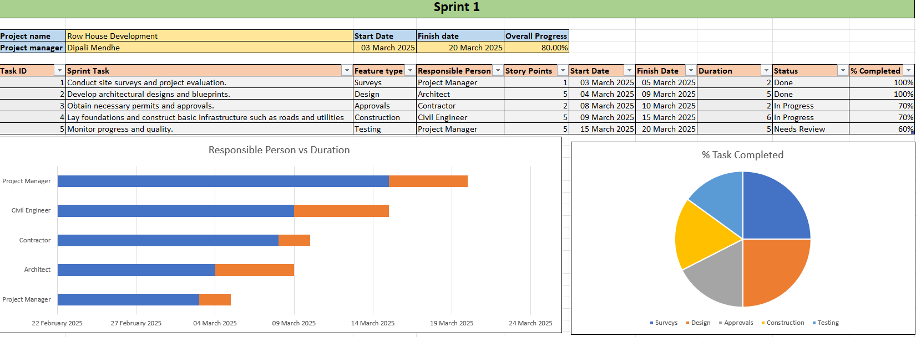

Figure . Sprint Planning

## Product Backlog

In this project we are continuously prioritize the backlog based on stakeholder feedback and project progress. Regularly updating user stories to ensure clarity and progress status. According to the product backlogs, sprint planning meetings are arranged and discuss the upcoming user stories and tasks. Conduct regular backlog grooming sessions to review and adapt the backlog based on changing project requirements. Below is the list of product backlog conducted till now:

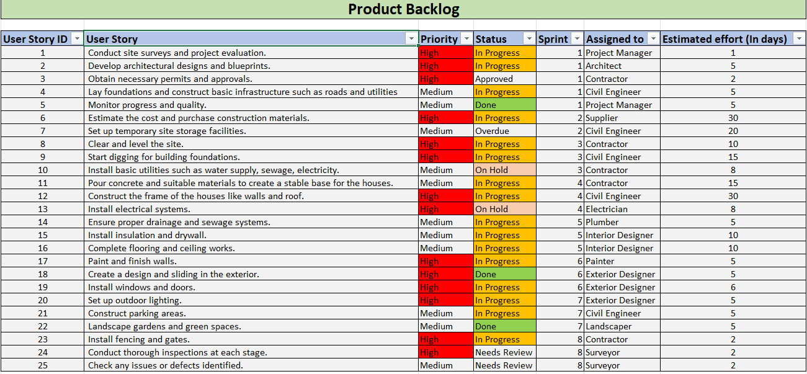

Figure . Product Backlog

## User stories

The construction of row houses has many phases and each phase involves stakeholder feedbacks. According the feedbacks the user stories has been created in this project and updated the work. Some of the user stories are as follows:

1. As an architect I want to create the design blueprint for the row houses, so that we have a clear plan to follow.
2. As a contractor, I want to acquire all necessary permits, so that construction can proceed legally and without delays
3. As a builder, I want to lay the foundation for the row houses, so that the structures are stable and secure.
4. As a supplier, I want to deliver all required materials to the construction site, so that work can continue without interruptions.
5. As an electrician, I want to install the electrical wiring, so that the houses have power.
6. As a landscaper, I want to create a garden and outdoor space, so that the houses have attractive surroundings.

## JIRA

JIRA board setup helps to manage and track our construction project effectively. Here I can adjust the priorities, statuses, and other details based on our project’s specific needs. As work progresses, I can update the status and comments for each user story. I have use filters to sort and view tasks by sprint, priority and assigned team member.



Figure . JIRA

# Conclusion

In constructing row houses involves different stages from planning and design to final handover. Each stage, including pre-construction, groundwork, foundation, exterior, interior works, and finishing, contributes to ensuring the durability, functionality, and quality of the final structure. Throughout the construction process, quality, standards and regulations is crucial to delivering safe and comfortable living spaces. The involvement of skilled professionals, from architects and engineers to contractors and inspectors, guarantees that each aspect of the construction is executed with precision and expertise.